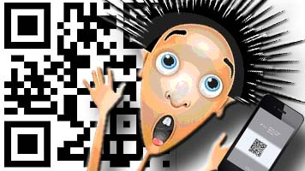
QR code Scavenger Hunt
http://goqr.me/

Location 1:

Task:
(Next Stop)

QR Code

Location 2:

Task:
(Next Stop)

QR Code

Location 3:

Task:
(Next Stop)

QR Code

Location 4:

Task:
(Next Stop)

QR Code

Location 5:

Task:
(Next Stop)

QR Code

Location 6:

Task:
(Next Stop)

QR Code

Student Groups

Group 1 | Group 2 | Group 3 | Group 4 | Group 5 | Group 6

